**GITAM INSTITUTE OF MANAGEMENT**

**GITAM (Deemed to be University)**

MID TERM

121913901009_A.LONICA­_R PROGRAMMING

1. (a) Find the class of the data type for below atomic vectors:
   * + 1. V <- FALSE
       2. A<-17.5
       3. D<-5+6i
       4. K<-"Analytics"

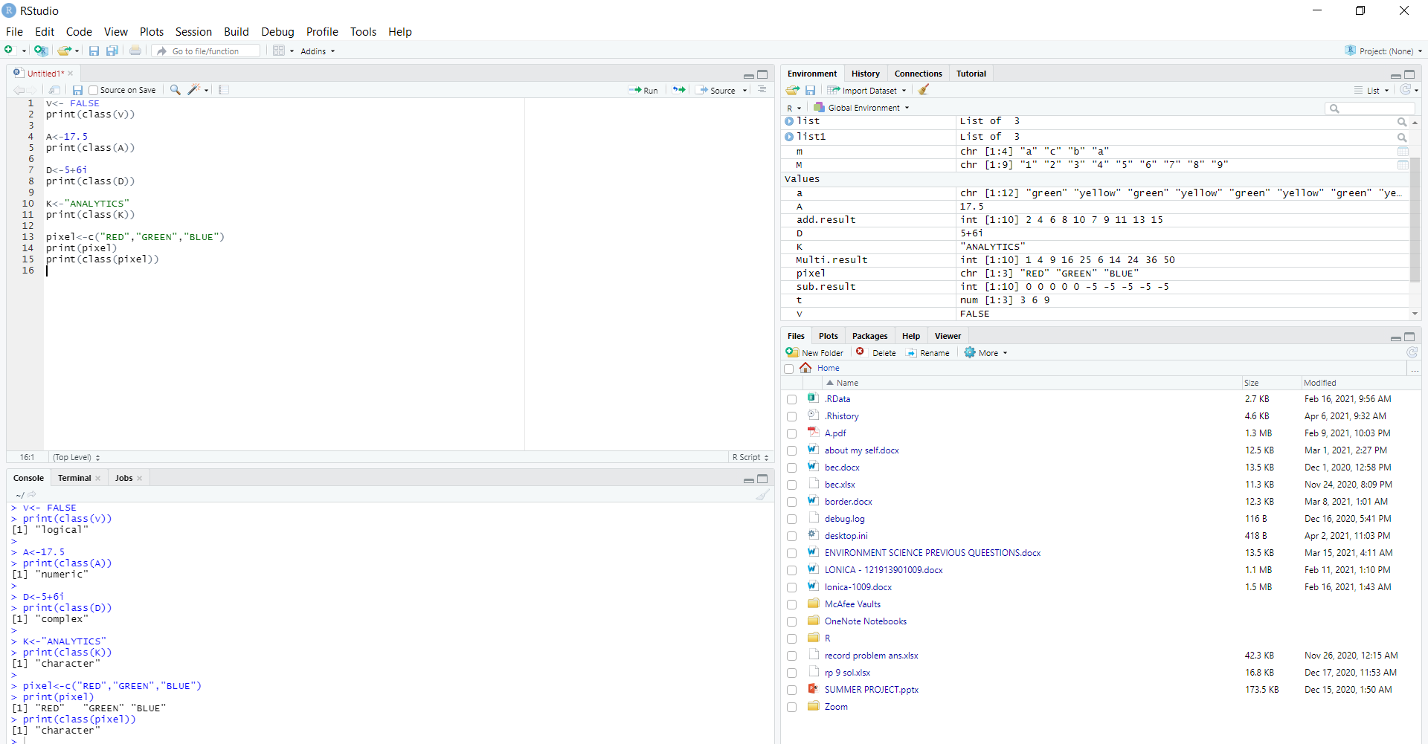

(b) Create a vector Named "Pixel" Consisting of three elements as RED, GREEN, and BLUE.

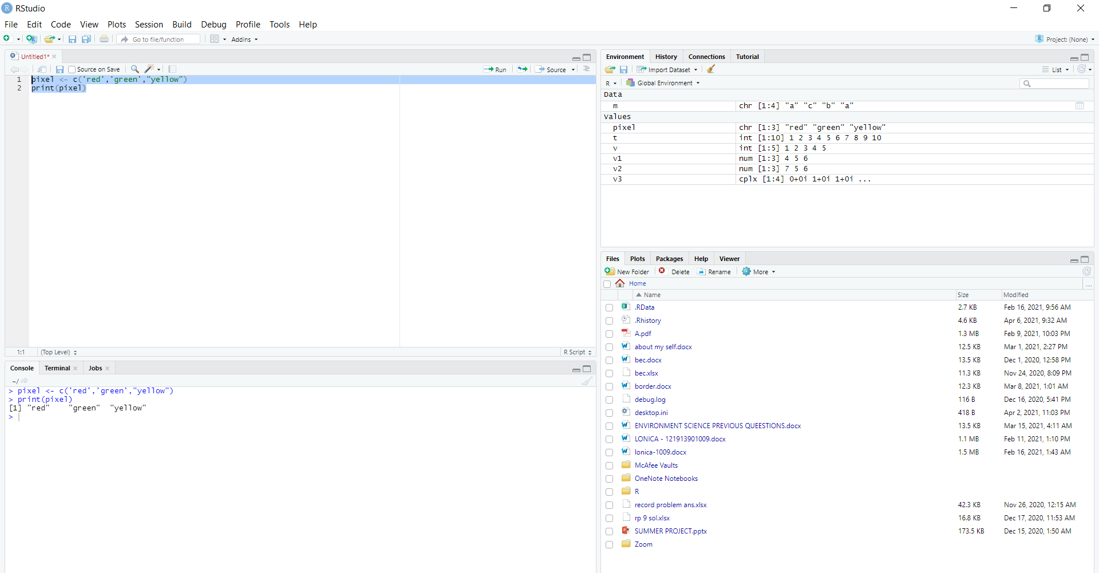

2. Create a list consisting of numeric values (21,32,11) and character (NORTH, SOUTH) data type elements.

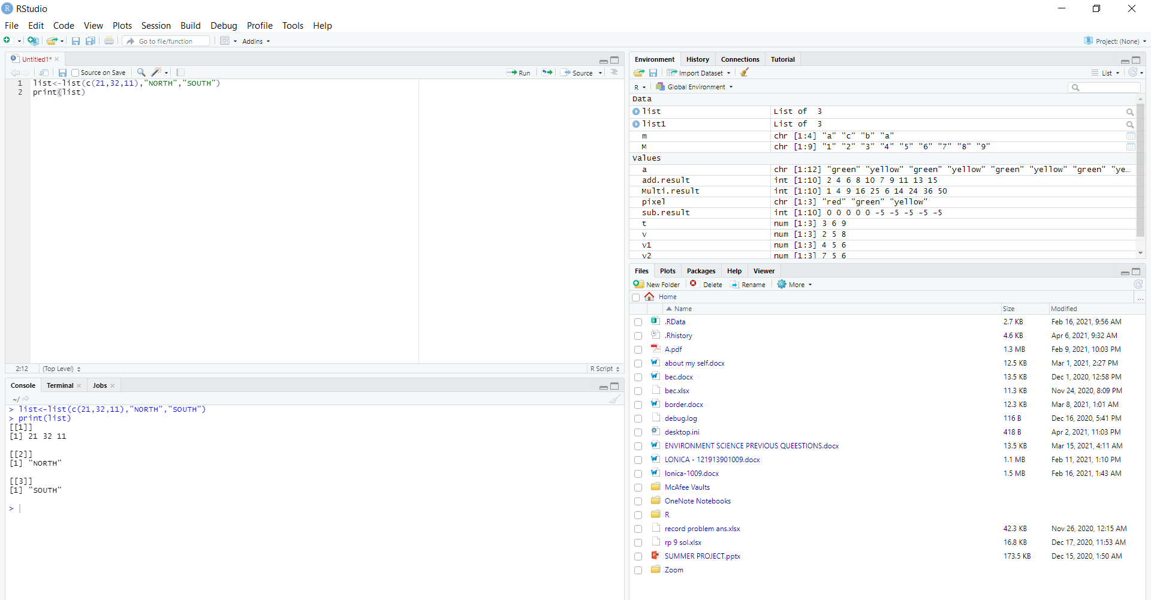

3. Create a Matrix consisting of nine elements (1 to 9) with three rows and three columns and fill the same by rows.

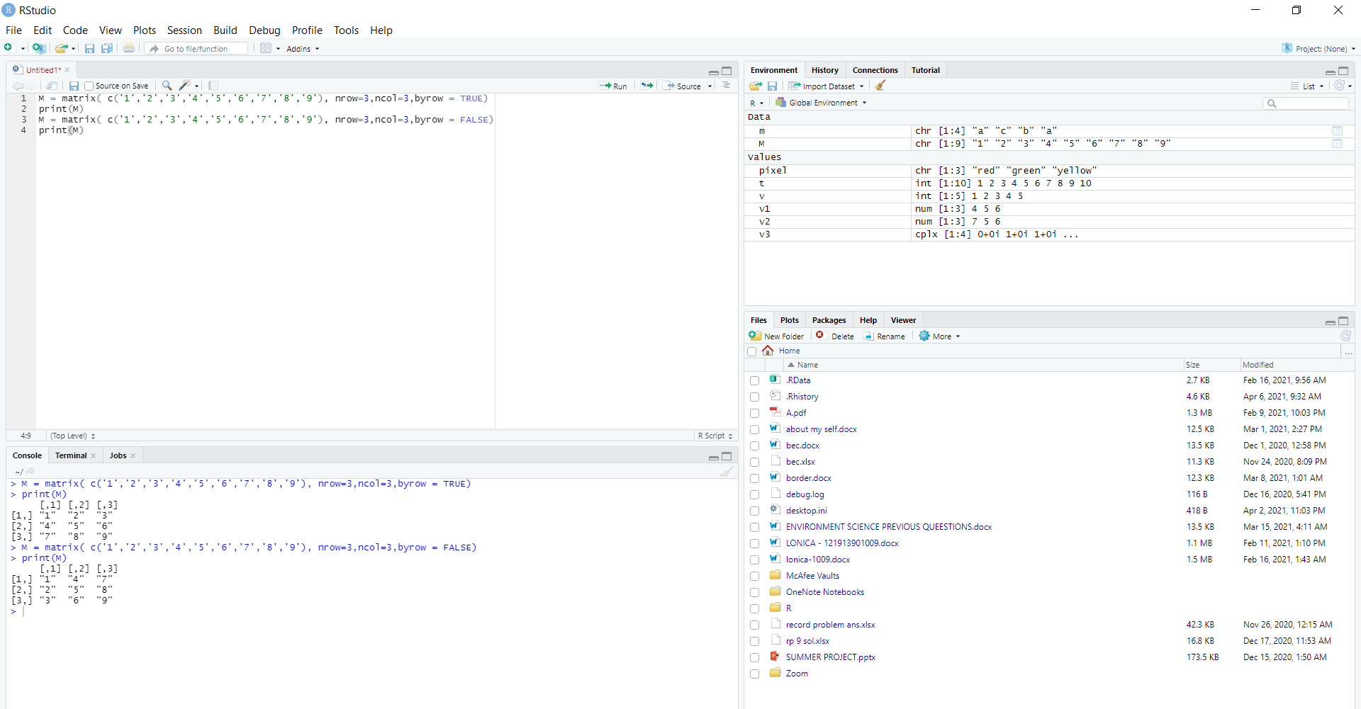

IN CASES OF TRUE AND FALSE

4. Create two vectors named v <- c( 2, 5, 8) , t <- c(3, 6, 9) and perform the following arithmetic operations: Addition, Subtraction and Multiplication between them.

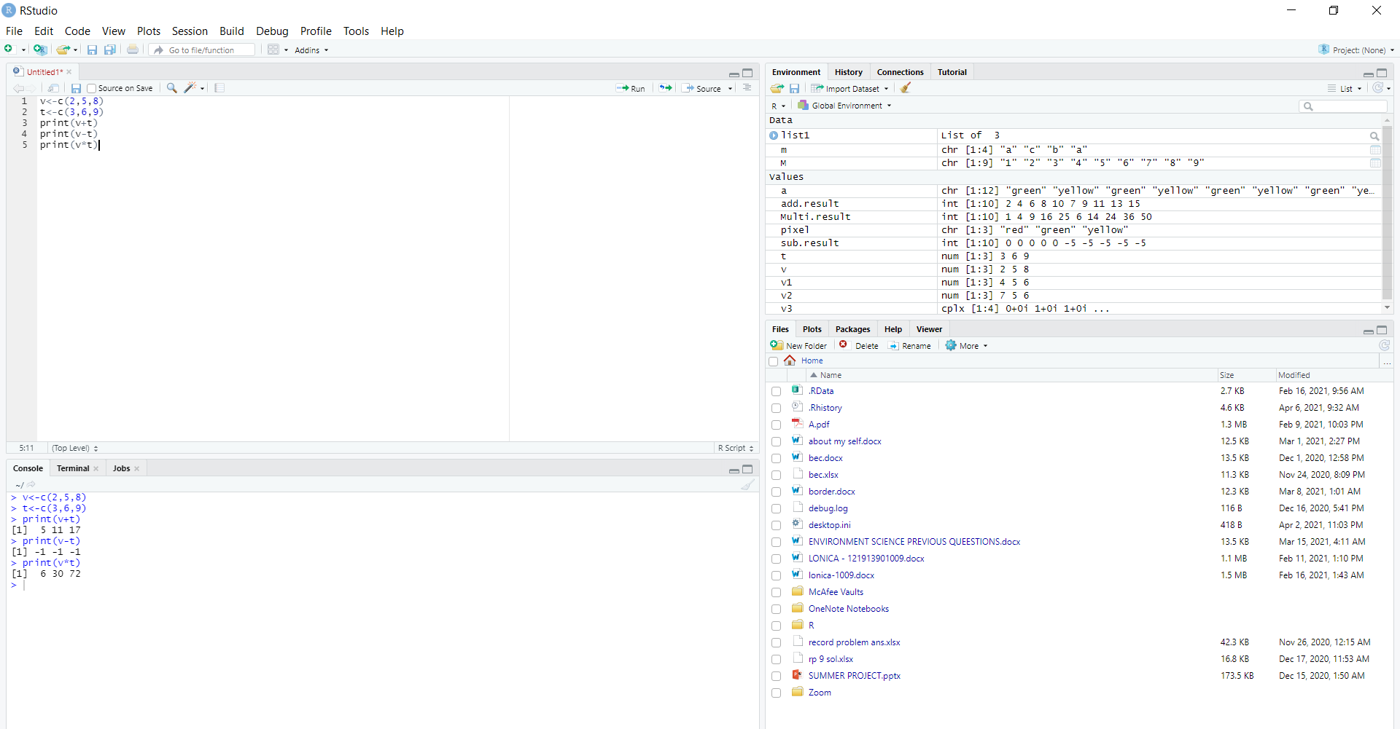

5. Create an array consisting of two elements (Green and Yellow) having two rows, three columns and two dimensions.

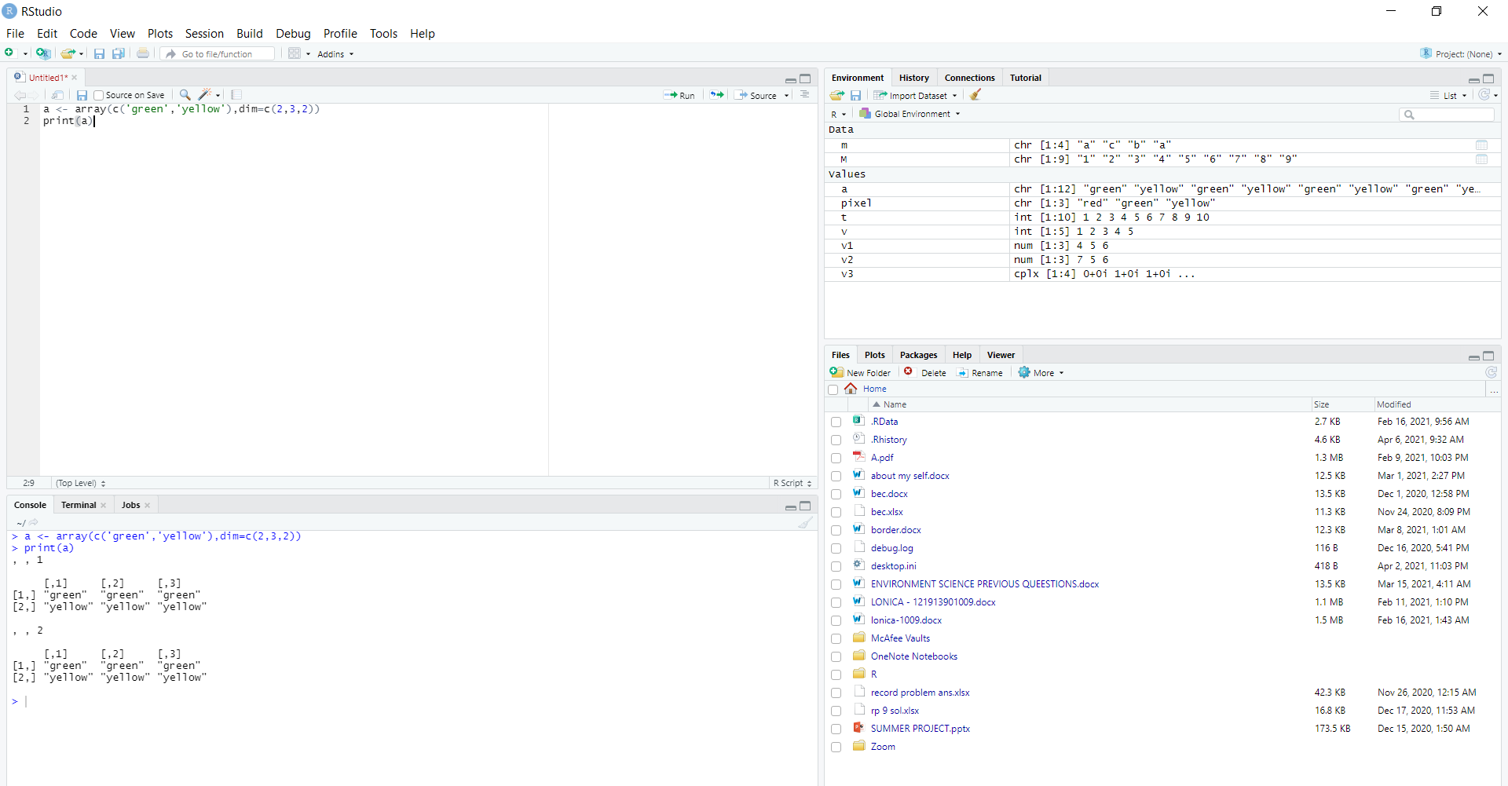

6.Create a data frame to achieve the below output.

emp_ id emp_ name salary

1 Rick 62000

2 Dan 51000

3 Michelle 61100

4 Ryan 72900

5 Gary 84000

